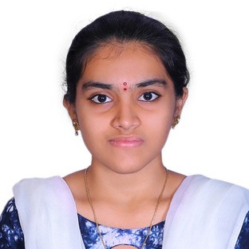DIVAKARUNI SRIKARANI

 Hyderabad

 +91 8341226952

[dsrikarani12@gmail.com](mailto:dsrikarani12@gmail.com)

**CAREER OVERVIEW**

Looking for a challenging role in a reputable organization to utilize my technical, database, and management skills for the growth of the organization as well as to enhance my knowledge about new and emerging trends in the IT sector.

# EDUCATION

SSC, Board of Secondary Education, Andhra Pradesh | 2019 | 9.5 GPA

Intermediate, MPC, Board of Intermediate Education, Andhra Pradesh | 2021 | 93.3% B.Tech, ACE Engineering College | 2025 | 7.49 CGPA

# TECHNICAL SKILLS

C

Java SQL

Python

**SOFT SKILLS**

Organizational skills Emotional Intelligence Active Listening Ethics

## ACHIVEMENTS

Certified from Cambridge assessment English at B1 level in Business English Certificate Preliminary (BEC-P)

Certificate in Joy of Computing using Python from NPTEL

Certified from Smart Internz in Partnership with AICTE on Salesforce Development Certified on RPA Citizen Developer Foundation, Automation for Students courses from UiPath

## FIELD OF INTREST

Cloud Computing

Machine Learning and Artificial Intelligence Big Data

## PERSONAL PROFILE

Date of Birth : 12th April, 2004 Languages known : English, Telugu, Hindi Father’s Name : D. Radha Krishna Mother’s Name : D. Saroja Rani

Address : Sri Venkateshwara Nilayam, Plot no 14

Street no.4, Sarada Nagar Phase 1, Near Sarada Nagar Busstop Vanasthalipuram, Hyderabad - 500070

## DECLARATION

I hereby declare that the above written particulars are true to the best of my knowledge and belief.



## SIGNATURE